**HVAC AI Admin Panel**

**User Types**

1. **Super Admin -** HVAC AI staff with full platform control
2. **Company Owner -** For Owners or determined people to control the Permission Matrix (Set a “Guess” now to be “Verified Professional" for example)
3. **Company Manager** - For Managers to view operation logs and monitoring
4. **Company IT Admin** - For the IT department of companies. Control user management and settings
5. **Investor -** For investors who require visibility into the company’s performance and growth

For reference:

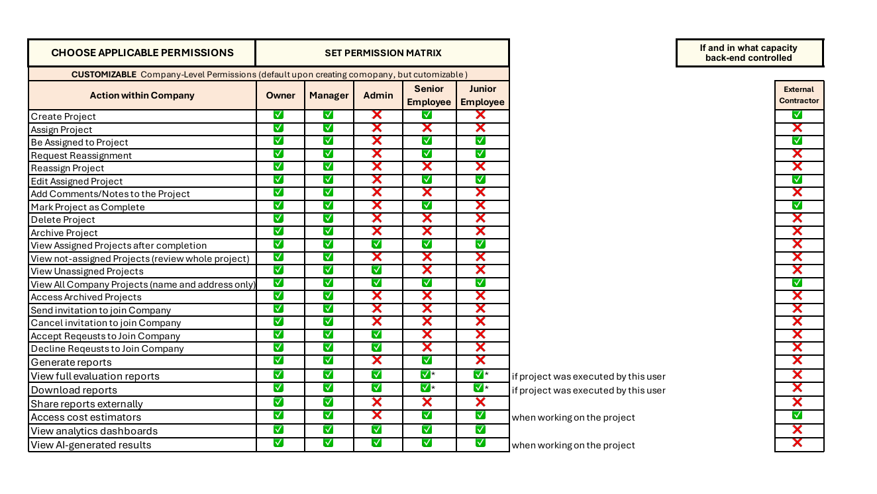

**Features**

1. **Platform Management System**

**Description :** This feature provides Super Admins a way to manage the whole platform. They can handle all customer companies in one place, including setup, daily operations, monitoring, and settings

**Goal:** Give Super Admins full control of the platform from a single page

**User Types :** Super Admins

1. **User Management System**

**Description :** This feature helps to manage all users within a company, from account creation to deletion. It works for both employees and outside contractors, making sure logins are secure, profiles are updated, and everyone has the right access.

**Goal:** Keep user access simple, safe, and compliant across the company

**User Types :** Super Admin , Company IT Admins , Company Owners

1. **Role Management System**

**Description :** This feature lets Company Owners set roles and permissions for users. They can decide who can see or do certain things, adjust user levels, and keep the platform secure. This makes sure everyone only has the access they need for their job

**Goal:** Ensure users only have the right access for their role while keeping the platform secure.

**User Types :** Super Admin , Company IT Admins , Company Owners

1. **Company Dashboard Analytics**

**Description :** This feature provides a dashboard with real-time data on how the company, users, and projects are performing. Each role gets a customized view with the metrics that matter to them.

**Goal:** Help companies track performance, make data-driven decisions, and improve results.

**User Types :** Super Admin , Company Owners , Managers

1. **Compliance & Audit Management**

**Description :**  This feature makes sure the platform follows all rules and regulations. It keeps detailed records of everything that happens—like user actions, system changes, and data access. It also creates reports that can be used for internal checks or external audits

**Goal:** Make sure the platform stays compliant with regulations, keep a clear history of all activities, and provide full transparency when needed

**User Types :** Super Admin , Company Owners , Managers

1. **Company Management**

**Description :** This feature helps to manage and organize company details, teams, and structures. It helps owners and managers keep company information updated and coordinate work across departments. To check the organization within the company and provide the due hierarchy.

**Goal:** Keep company details, teams, and structures organized and easy to manage

**User Types :** Super Admin , Company IT Admins , Company Owners , Managers

1. **Project Management**

**Description :** This feature helps Business Owners and Managers easily follow projects from start to finish. They can manage and reassign tasks within projects, and quickly transfer tasks if a worker leaves the company.

**Goal:** To supervise project status, keep tasks organized and easily handle changes when workers leave.

**User Types :** Super Admin , Company IT Admins , Company Owners , Managers

1. **Equipment Management**

**Description :** This feature helps tracking all company equipment. It shows where each item is, its condition, maintenance history, and which projects it’s used in. Managers can also add or remove equipment as needed.

**Goal:** Help the company easily manage all equipment, keep it in good condition, and know exactly where and how it’s being used.

**User Types :** Super Admin , Company IT Admins , Company Owners , Managers

1. **License and Subscription Management**

**Description :** This feature helps manage customer subscriptions and licenses. It takes care of billing, who gets access, how much they use, and renewals. Works for both single users and big companies.

**Goal:** Makes billing accurate, helps keep customers from leaving, and allows the company to offer different pricing options as customers grow.

**User Types :** Super Admins

**EPIC Statements - HVAC AI Admin Panel**

**\* Note: When the Epic Statement recalls the word “User” refers to all of the User Type**

1. **Platform Management System - EPIC Statement**

As a **Super Admin**, I need to monitor and manage multiple companies, users, logs, and configurations from a single platform. I require proactive management tools with context awareness to easily locate information, generate reports, and assign roles and user types to users across all companies

1. **User Management System - EPIC Statement**

As a **User**, I need to manage the entire HVAC AI user lifecycle. I want a clear view where can I quickly search for a user by name or ID, access their full profile details, and easily update any necessary information

1. **Role Management System - EPIC Statement**

As a **User,**  I need to manage roles within my company by assigning, switching, and customizing roles for each team member. This way, I can ensure they have the exact level of access required to do their work efficiently, without exposing sensitive data or critical operations

1. **Company Dashboard Analytics - EPIC Statement**

As a **User ,** I need to review a company’s performance and team productivity in a clear, actionable format, so that I can make informed, data-driven decisions. I also need the ability to customize how this information is presented to fit my specific needs

1. **Compliance & Audit Management - EPIC - Statement**

As a **User,** I need to be able to have a complete activity tracking system that records all user actions (e.g., project creation, deletions, photo removals, role changes) so that I can ensure compliance, accountability, and data integrity within the platform

1. **Company Management - EPIC Statement**

As a **User**, I need to manage the structure and organization within my company. I should be able to view detailed company information and edit it when necessary. I also need the ability to create and organize teams, departments, and hierarchies in a flexible way, as well as manage external contractors, so that the company structure accurately reflects how we operate.

1. **Project Management - EPIC Statement**

As a **User**, I need to review the projects created within the HVAC AI platform. I should be able to easily view project members, deadlines, and project assets (such as photos and documents), as well as track progress over time. This will ensure projects are delivered efficiently, on schedule, and with full visibility into responsibilities and milestones.

1. **Equipment Management - EPIC Statement**

As a **User**, I need comprehensive equipment management within every project, including the ability to add, update, or remove equipment, and maintain historical logs. This ensures full lifecycle visibility and traceability of all equipment across projects

1. **License and Subscription Management - EPIC Statement**

As a **Super Admin,** I need to manage company licenses and subscriptions for the HVAC AI app. I should be able to visualize and assign subscription plans, track usage limits, renew or upgrade licenses, and monitor billing details. This ensures that every company has the appropriate access level, avoids service interruptions, and maintains compliance with contractual agreements